|  |  |
| --- | --- |
| Student Name | **Arbab Hussain Qureshi** |
| Roll Number | **22SW028** |
| Section | **01** |

**DBS LAB # 7 – JOINS IN SQL**

1. **Write a query to display the employee name, department number, dept name and dept location for all the employees.**

**Output:**

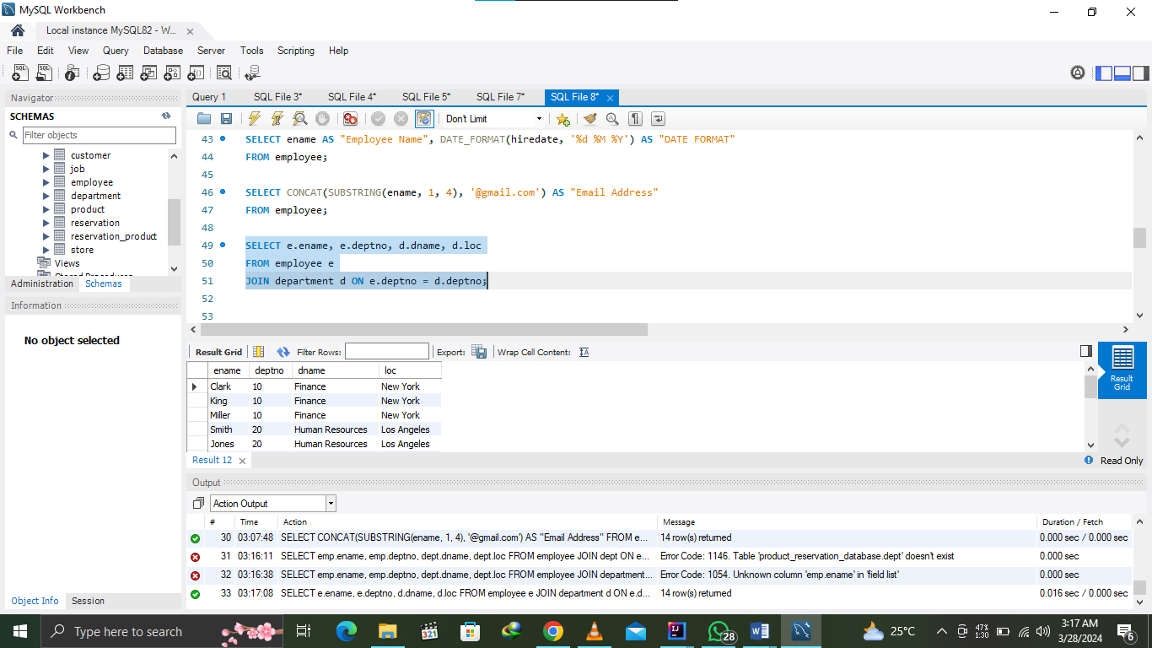

1. **Create a unique listing of all jobs that are in dept 30. Include the location of department in the output.**

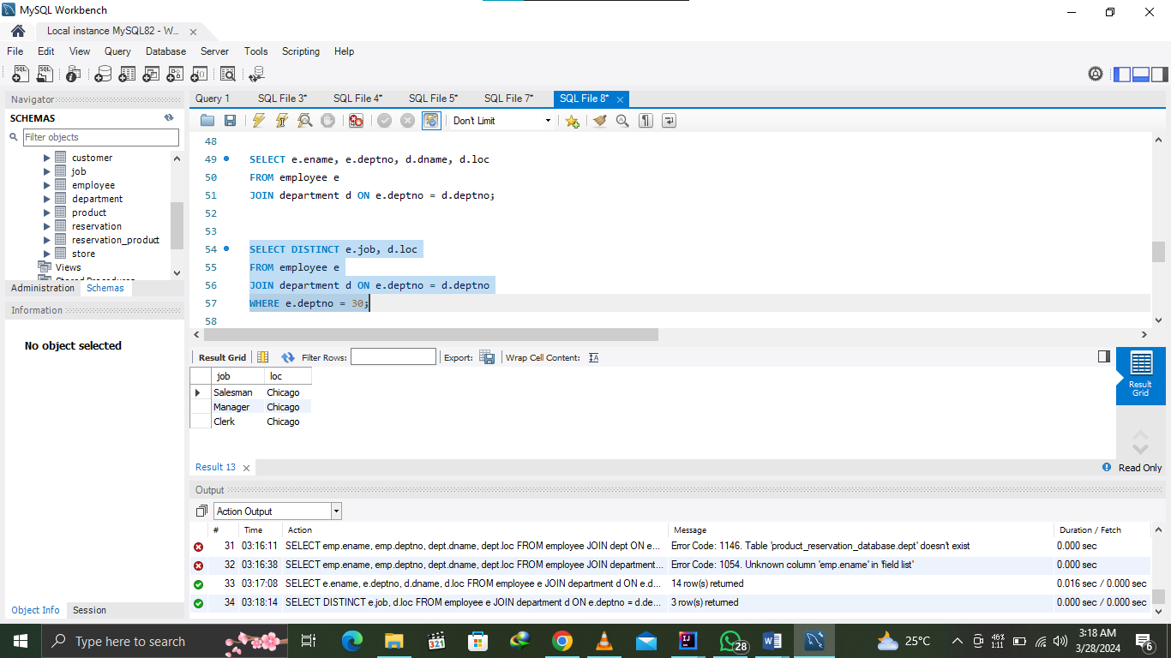

1. **Write a query to display the employee name, emp sal, department name, dept location of all employees who earn a commission.**

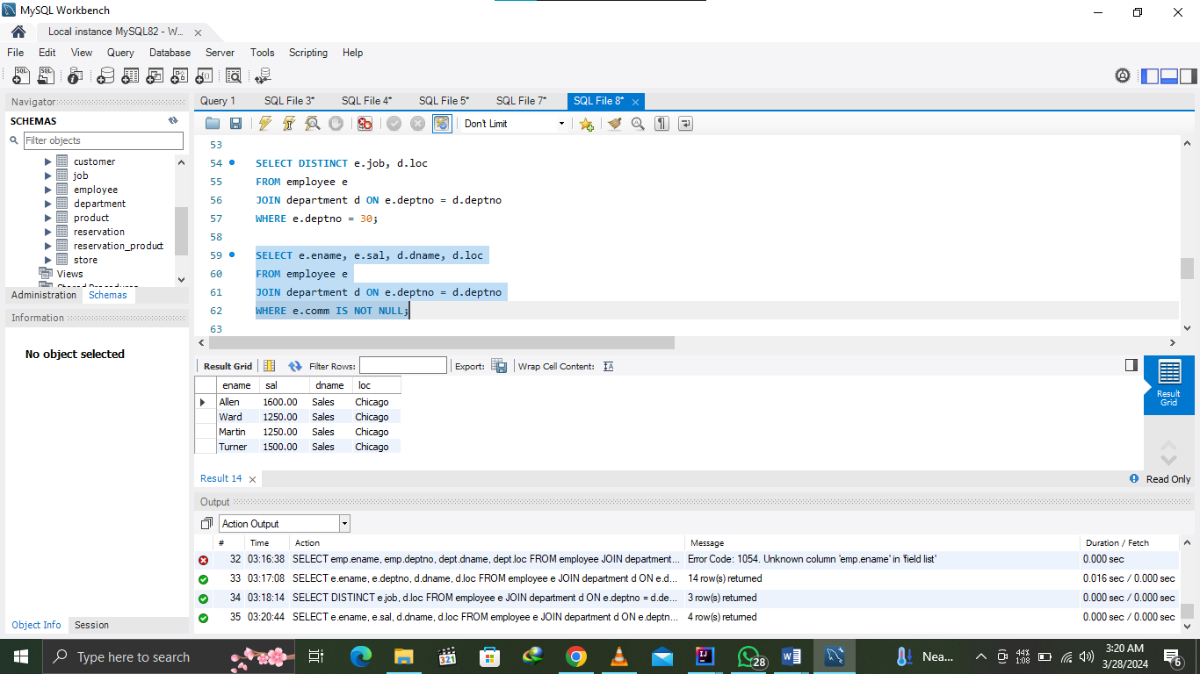

1. **Write a query that lists empno, ename, mgr id and dname from emp and dept table.**

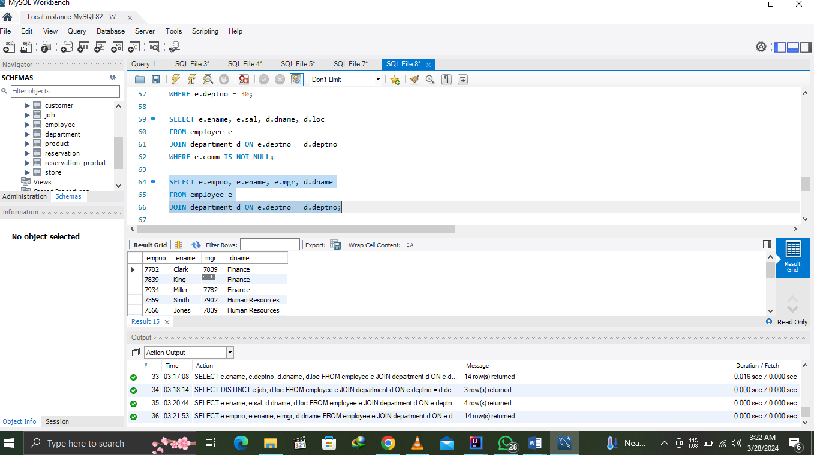

1. **Write a query that returns all the employees, their related information and dept name and even those department where no employee is working.**

